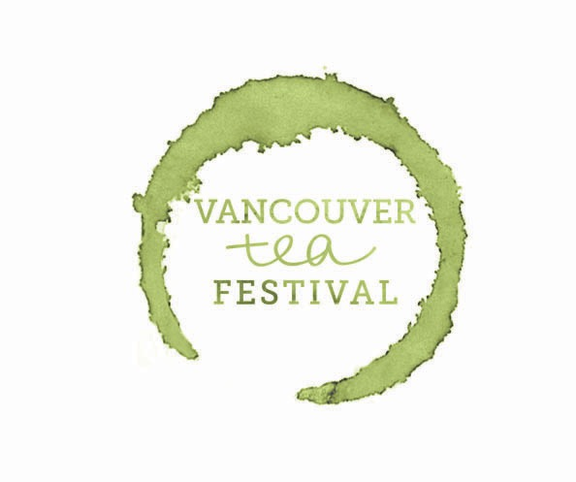
VANCOUVER TEA FESTIVAL
Saturday, 5 November 2016 ~ 10 AM - 6 PM
Chinese Cultural Centre of Greater Vancouver & Dr. Sun Yat-sen Classical Chinese Garden Vancouver, BC
Challenging conventional belief that Vancouver is a city consisting solely of coffee lovers, the Vancouver Tea Festival has, in just a few short years, become Western Canada’s largest, proving beyond the shadow of a doubt this is a city that profoundly loves its tea as well.
After drawing thousands upon thousands of tea lovers from around British Columbia, Washington, and Oregon to the first two iterations of the Vancouver Tea Festival, Vancouver Tea Society is elated to announce the return of its flagship event this November to Vancouver’s historic Chinatown neighbourhood!

The exhibition portion of the 2016 Vancouver Tea Festival will take place Saturday, November 5th, 2016, from 10 AM - 6 PM at the Chinese Cultural Centre (CCC) of Greater Vancouver (50 E. Pender St., Vancouver). Other events occurring during the festival, including presentations and tea tastings, and some non-retailing exhibitors, will be located at the adjacent Dr. Sun Yat-sen Classical Chinese Garden (578 Carrall St., Vancouver).
Presented by Vancouver Tea Society.
The exhibitor fee for the 2016 Vancouver Tea Festival is as follows (inclusive of tax, but exclusive of electricity surcharge):
* Super Premium - CAD $550 per table
* Premium - CAD $500 per table

- Regular - CAD $400 per table for returning exhibitors; CAD $450 per table for new exhibitors
Exhibitors may purchase as many tables as they wish, subject to Vancouver Tea Society approval, at these quoted rates.
All exhibitors purchasing single booths who will require any electricity - even if no kettles or other energy-intensive appliances will be used - must purchase a CAD $50 electricity surcharge. This surcharge will entitle the exhibitor to a quantity of electricity sufficient to power a maximum of one (1) kettle and a reasonable amount of supplementary electrical appliances and/or electronics (subject to Vancouver Tea Society’s discretion).

Exhibitors purchasing double booths will have their electricity surcharge waived. This waiver is subject to cancellation at the discretion of the Vancouver Tea Society board if an exhibitor who has purchased a double booth is deemed to be using an excessive quantity of electricity. In cases of waiver cancellation, payment of the full electricity surcharge will be due seven (7) calendar days following the conclusion of the festival.

TERMS & CONDITIONS

Payment in full is due immediately upon selection of your exhibitor booth(s). Delay in payment without the express written consent of Vancouver Tea Society, or rejected payment, may result in cancellation of your application and/or reallocation of your exhibitor table at Vancouver Tea Society's sole discretion. In this instance, Vancouver Tea Society will provide no compensation.
In the event you cancel your table, refunds will be issued as per the following:
* Cancellation on or before August 1: 75% of the table fee refunded.
* Cancellation on or before September 1: 50% of the table fee refunded.
* Cancellation after September 1: No refund.
Vancouver Tea Society reserves the right to limit the number and type of exhibitors to ensure an appropriate variety of exhibitors. Vancouver Tea Society also reserves the right to alter the booth layout at any time, and may, following consultation with an exhibitor, reassign or otherwise change an exhibitor’s previously selected booth location at its sole discretion. While every effort will be made to ensure exhibitor satisfaction if this decision is taken, no compensation of any sort will be provided by Vancouver Tea Society to the exhibitor.
Exhibitors shall comply with venue rules and regulations regarding display materials and safety. Exhibitors are liable to the venue owners for any damage they, or anyone accompanying them, cause.
Exhibitors are required to remain at their booths until the festival closes at 6 PM, Saturday, November 5th, 2016. Excluding extenuating circumstances, exhibitors who tear down or otherwise abandon their booths prior to this time without prior express consent from Vancouver Tea Society may, at Vancouver Tea Society's sole discretion, be barred from future Vancouver Tea Festival events.

Immediately following the close of the festival, exhibitors must clear and wipe down their table(s) and remove everything from their allotted space (including all trash) except those items provided by the venue. All garbage is to be properly disposed of; failure to do so will be the liability of the exhibitor and may result in additional charges to the exhibitor.
Pricing

Exhibitors who are wholesalers or who have a wholesale component to their business will be subject to minimum-pricing requirements, as determined at the sole discretion of Vancouver Tea Society, if conducting retail sales at the Vancouver Tea Festival. Non-compliance will result in booth closure until retail prices are adjusted to the satisfaction of the Vancouver Tea Society board. Repeated infractions may result in a permanent ban from future festivals.
What do you get with your booth?
- 1 10'x10' booth
- 1 6-foot (1.8m) table with black tablecloth
- 2 chairs
- Black drapery (full-height back and half-height side drapery)
- Hot water (temperatures above 80 Celsius / 175 Fahrenheit cannot be guaranteed; exhibitors who require higher temperatures will be subject to an electricity surcharge)

What is not included with your booth?

- Electricity - No electricity AT ALL will be provided for exhibitors who have not paid the electrical surcharge
- Garbage/compost receptacle (there will be general collection but you must provide your own as well if giving out samples)
- Thermos® or similar vessel - please bring your own to hold hot water*
- Extension cords.

*Hot water (up to 80 C / 175 F) will be supplied and distributed by volunteers, but we recommend bringing your own Thermos®-type vessels as a back-up.

All display materials, including freestanding displays, must fit entirely within your allotted 10'x10' booth. Display materials are not permitted in the aisles. Exhibitors whose displays do not fit entirely within the allotted space will, at Vancouver Tea Society's sole discretion, be required to alter or remove such displays. Failure to comply with this requirement will result in a permanent ban from future Vancouver Tea Festival events.

All Vancouver Tea Festival exhibitors must complete a Vancouver Coastal Health (VCH) Temporary Food Services Application to participate in the festival; there is no cost associated with this permit. This application form is available at http://www.vch.ca/media/Temporary_Food_Services_Application_July_23_15.pdf . All completed forms must be submitted to Stephanie@vancouverteafestival.ca by midnight Saturday, October 1st. VCH will issue the appropriate permit for each vendor as required. Exhibitors who do not submit their completed form by the October 1st deadline will be unable to serve any food products (including ice) at their booth(s).

Projected attendee numbers are estimates only. While we believe in the accuracy of any quoted estimates, Vancouver Tea Society cannot guarantee attendance levels, and no compensation of any sort will be provided to exhibitors in the event estimated attendance figures are not met.

Exhibitor tables are non-transferable without express written permission from Vancouver Tea Society. Upon communicated approval of an exhibitor's application, the terms and conditions set forth shall be in force.
By signing below, you, the exhibitor, acknowledge you have read and agree to the terms and conditions stated above. You agree you will not hold Vancouver Tea Society or its directors responsible for loss, damage, or theft of any items. You understand that you are an independent exhibitor and assume all liability in any way related to your participation in the event, including the liability of any non-participants who accompany you.
Signed,
__________________________________________
on behalf of

__________________________________________

This _____________day of ______________, 2016.

